Open CV

At this task I had watch a course [كورس كامل بالعربي للمبتدئين OpenCV with Python - YouTube](https://www.youtube.com/playlist?list=PL1w7noagV-ZfLMTd6aF-K4ZqkCc7jr-K1) to get the basic for cv

At the beginning I had to install cv2 by using (pip install cv2)

**Phase 1**

**A**

I had show the original photo for reference

.imread is a function to call the photo or the source

Then you have to sesize the photo to show it

waitKey is used to make the closing time to zero

destroyAllWindows to not get stuck between another photos or data

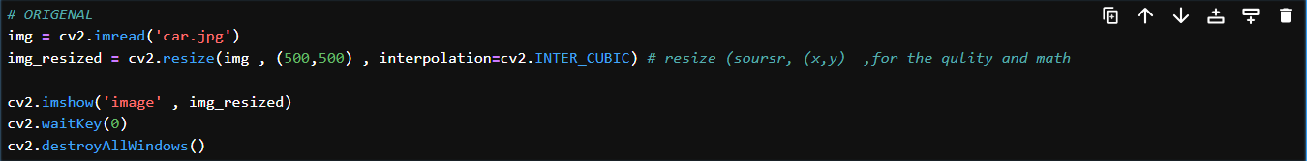

**B**

In this phase I had turn the color of the photo from RGB to Grayscale

You have to use cv2color to change the color of the photo its have 2 parameters the first one is the data source and the second one is the color you want to change to

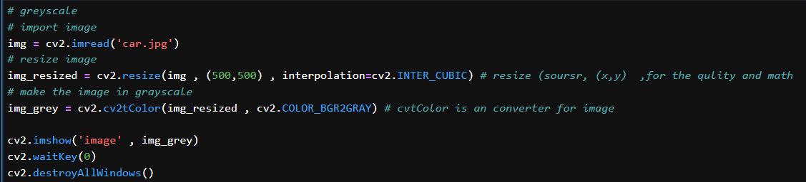

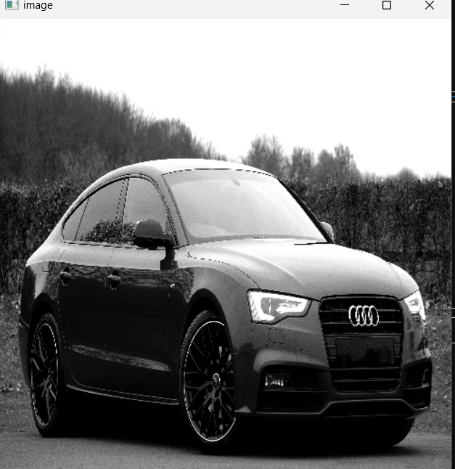

**Phase 2**

**A**

This part will open your pc cam

You have to use cv2.VideoCaptuere(0) why zero? Your default cam will be 0 if you have another one its going to be 1 an so on

The difference here we used the (X) later as the exit button as you see in line 5

**B**

**Define Canny_detector Function**

* Color images are converted to grayscale, as edge detection operates on intensity changes.
* A Gaussian blur smooths the image to reduce the impact of noise which might otherwise produce false edges.
* Computes horizontal (x-direction) and vertical (y-direction) intensity gradients using Sobel operators.
* Converts these to magnitude and angle for each pixel.
* Initializes "weak" and "strong" edge thresholds as fractions of the maximum magnitude found.
* Classifies pixels as strong edges, weak edges or non-edges based on the calculated thresholds.

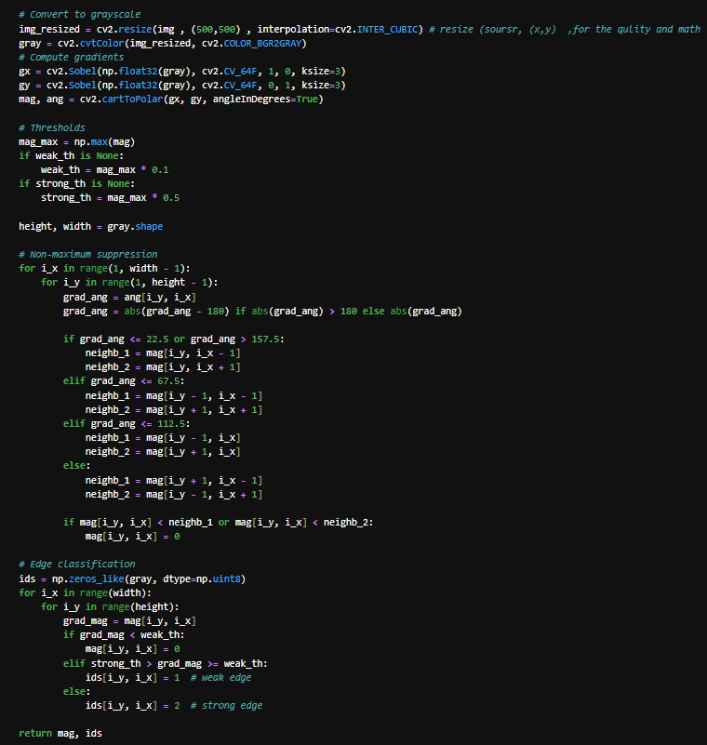

Read and return a check if the photo is not found

Call the function



Show the result



